Figures-Methods and Results (Draft)

1. Introduction

2. Methods

2.1 Study Sites
Figure 1. Sediment Deposition Processes with Structural, Biotic, and Abiotic Factors (reproduced from Leondari 2018)
Figure 2. Scarp Marsh Edge Shape and Sediment Deposition Processes (reproduced from Fagherazzi 2020)
Figure 3. General Study Site
Figure 4. General Study Site with Elevation Survey Benchmarks Included

2.2 Marsh Edge Typology

2.3 Sediment Deposition Collections throughout the Year
Figure 3. Transect Layout of Study Design With Ramped and Scarped Edges
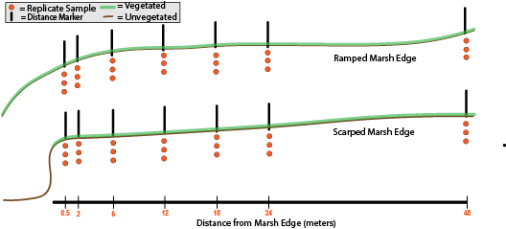
Figure 4. Deployment Length within Study Period (2022-2023) 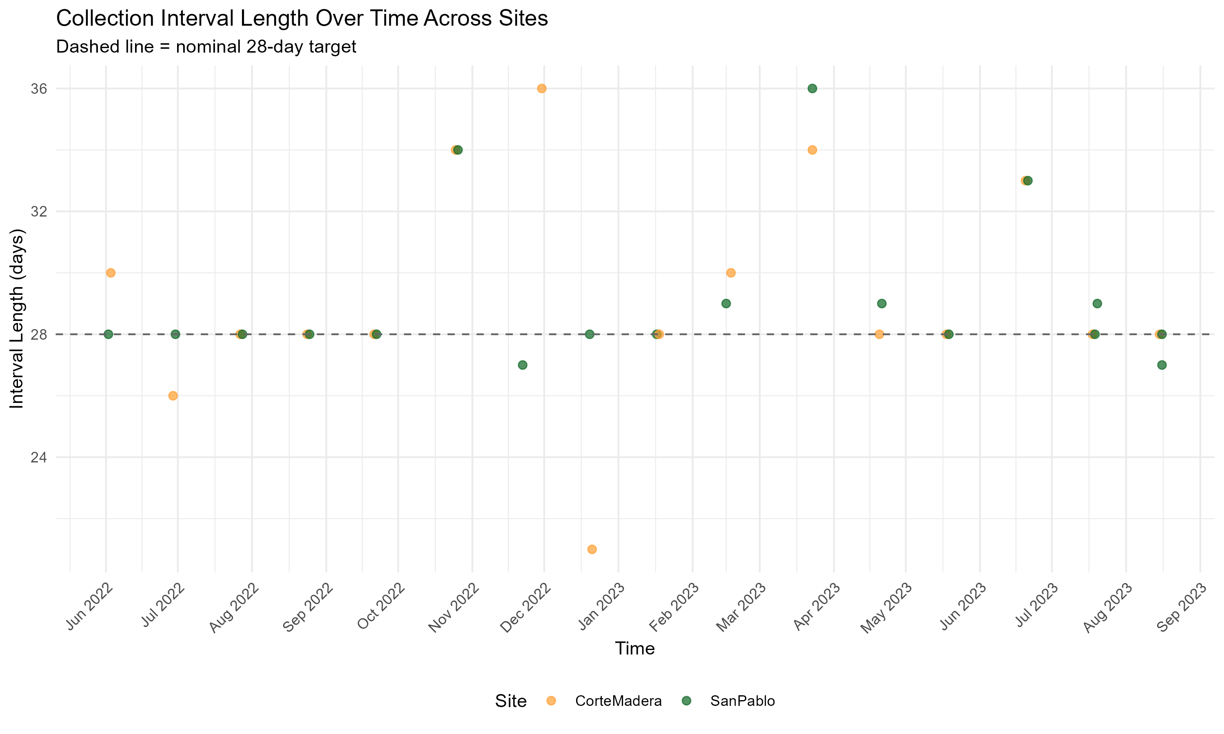
Figure 5. Deployment Length within Study Period (2025-2026) 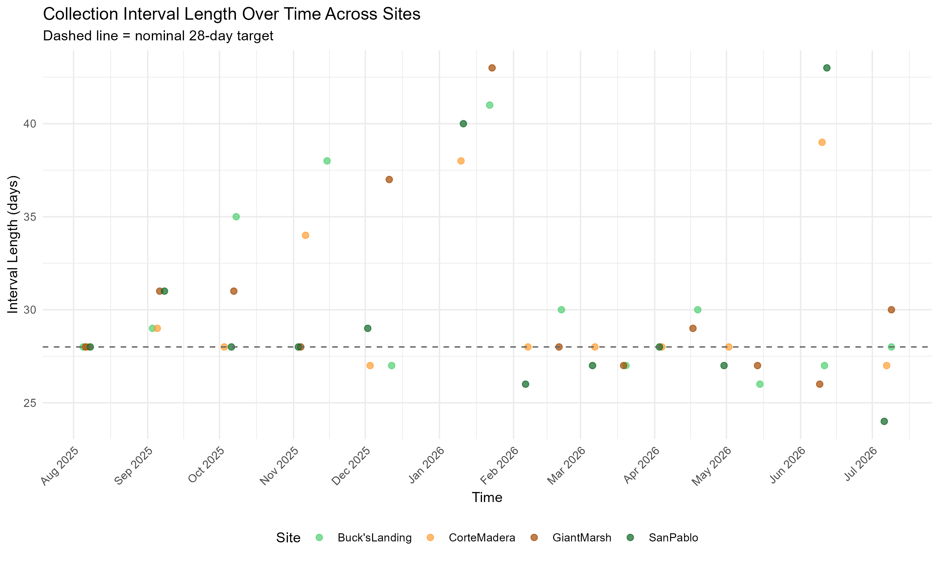
Figure 6. Criteria Table for Qualitative and Quantative Quality Control Determinations 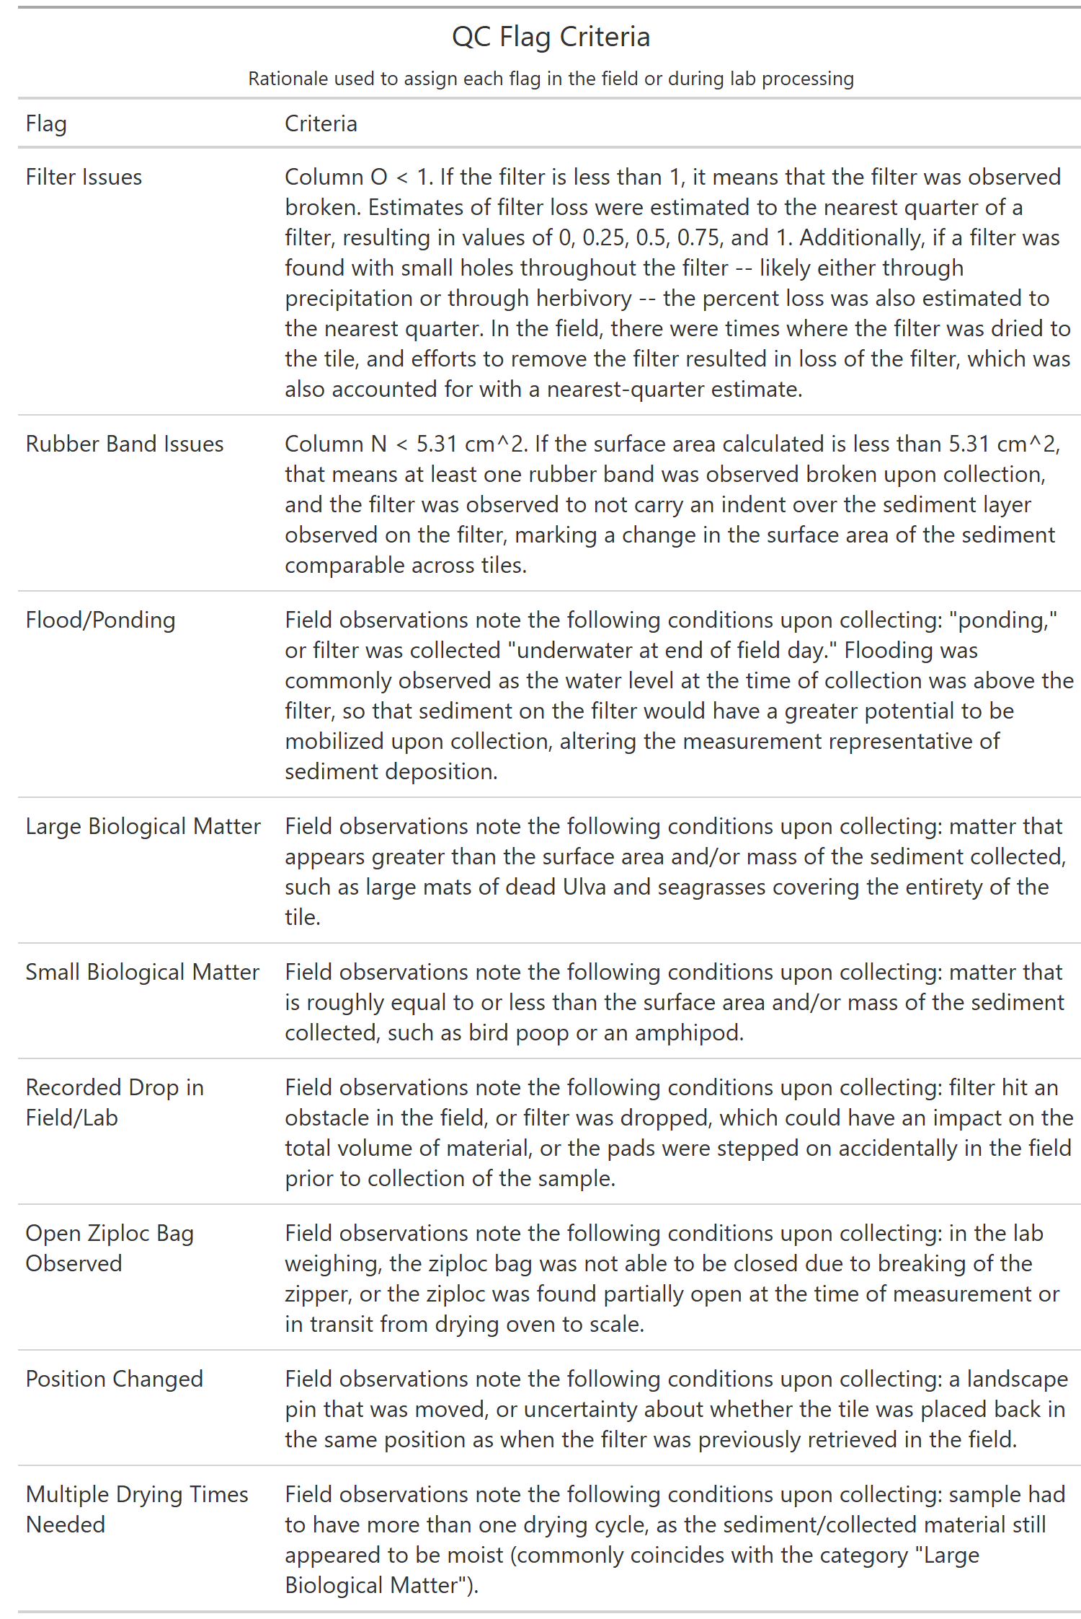

3. Results

3.1 RTK Elevation Measurements for Horizontal Marsh Edge Profiles of 2025-2026 Study
Figure 7. Elevation Profiles of Scarped Edges Sites-Giant Marsh and Corte Madera 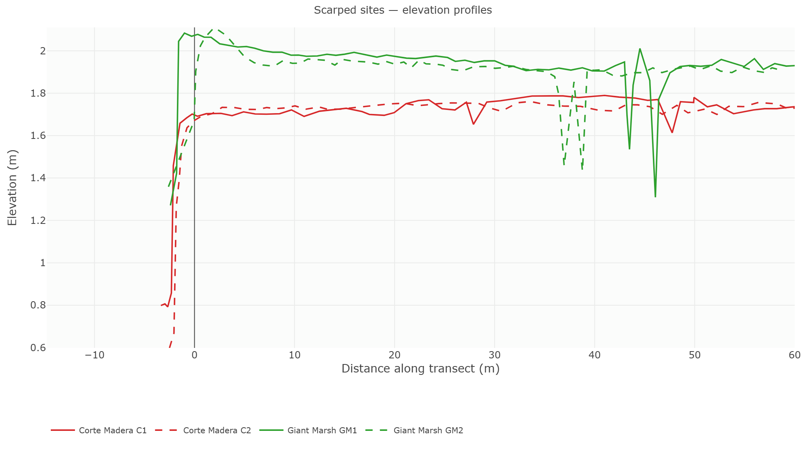
Figure 8. Elevation Profiles of Ramped Edges Sites-Buck’s Landing and San Pablo 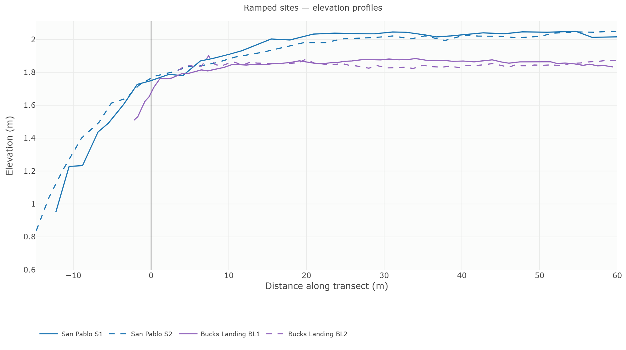
Figure 9. Quality Control Results by Study Phase Collected
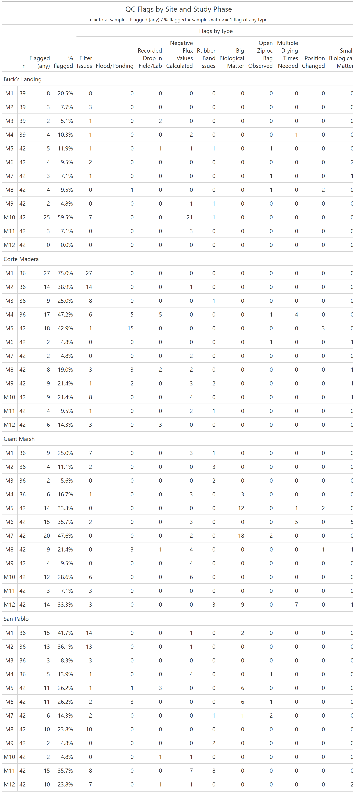
Figure 10. Quality Control Results by Distance from Marsh Edge
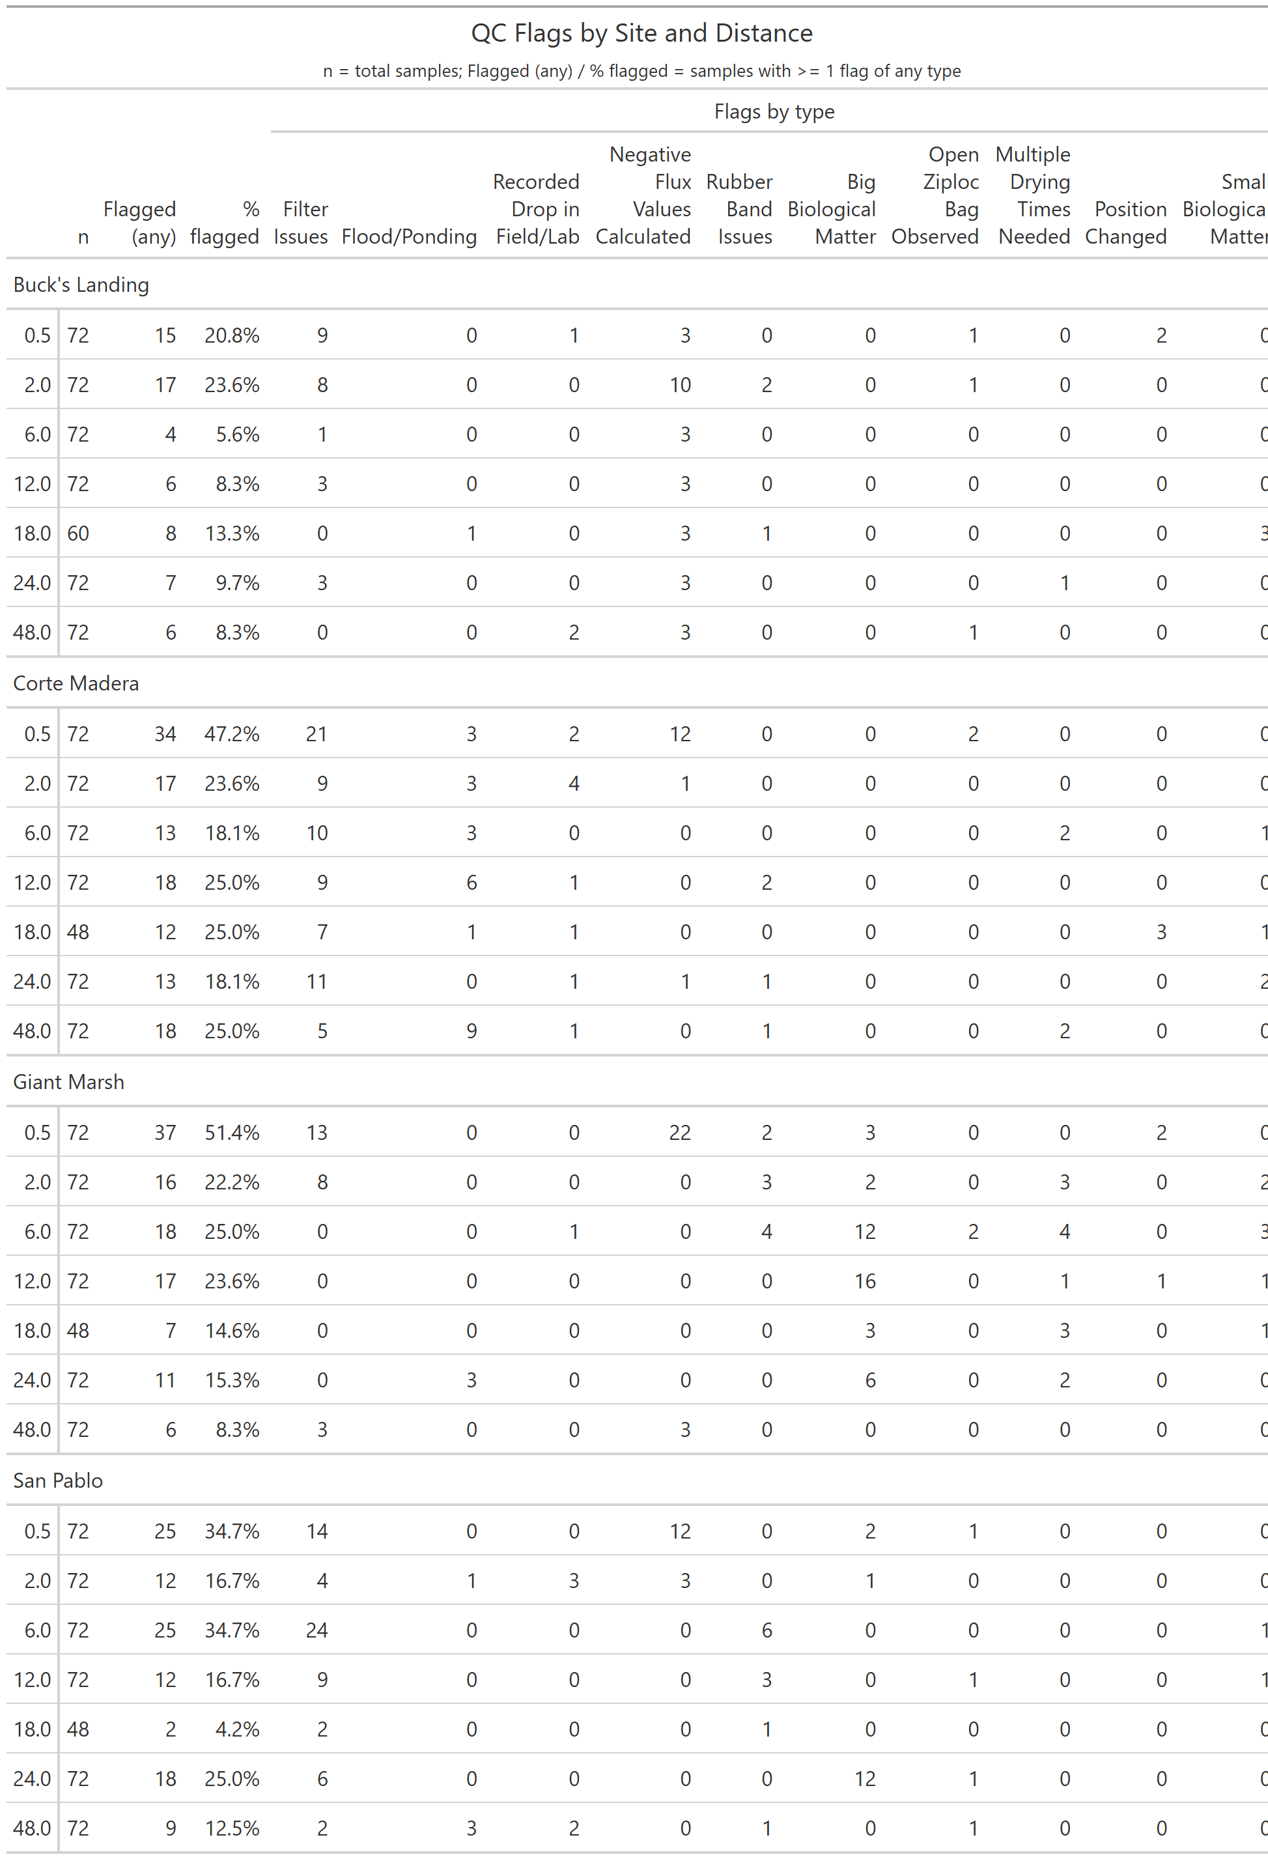
Figure 11. Quality Control Flag Frequency Per Distance Sampled
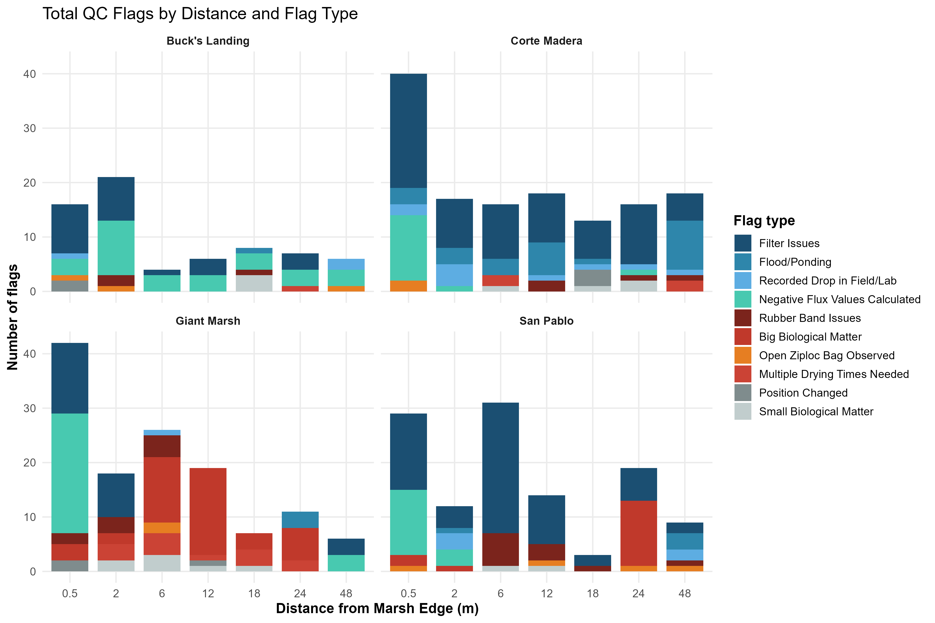
Figure 12. Total Percentages of Flags Occurred within Site
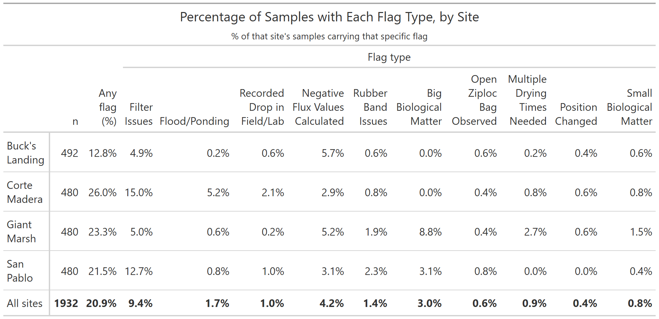

3.2 Sediment Deposition Across Ramped and Scarped Marsh Edges
Figure 13. Sediment Flux Across Ramped and Scarped Marsh Edges in 2025/2026
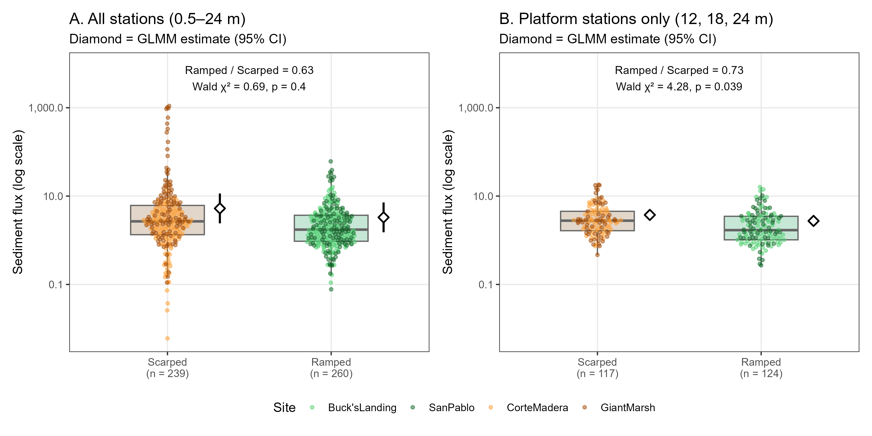

3.3 Comparing 2022/2023 and 2025/2026 Flux Across Corte Madera Marsh
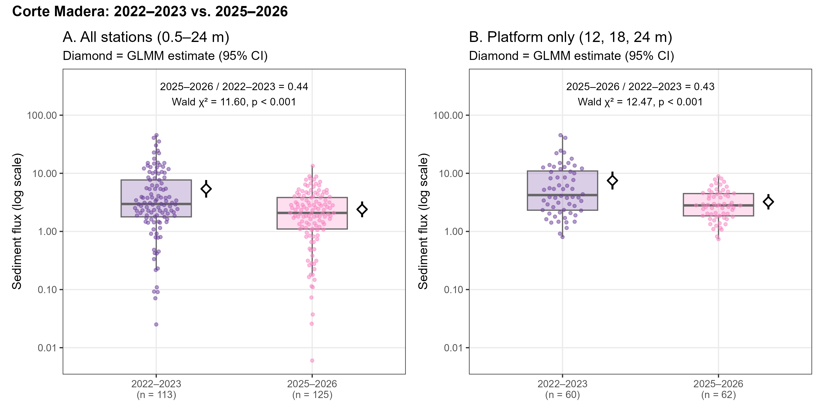

3.4 Sediment Deposition in Relation to Intra-Marsh Geomorphic Factors
Intra-Marsh Geomorphic Factor Comparison
Figure 22. Least Absolute Shrinkage and Selection Operator (LASSO) Regression Model of Intra-Marsh Geomorphic Variables
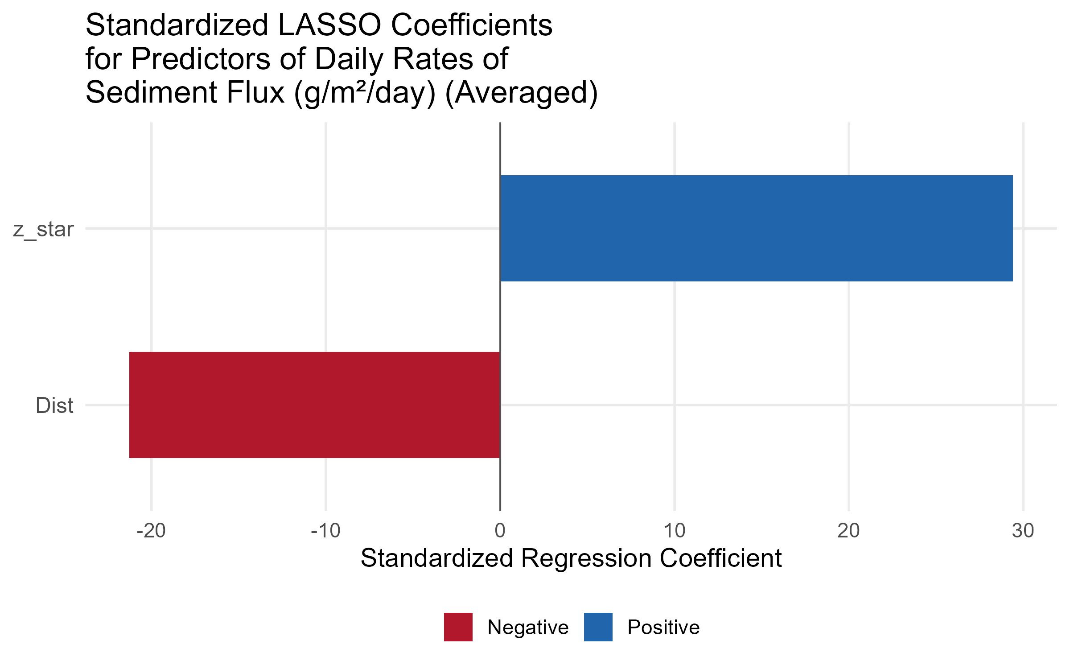
Elevation and Distance from Marsh Edge
Figure 23. Comparing Average Flux and Variability Across Distance from Marsh Edge and z star
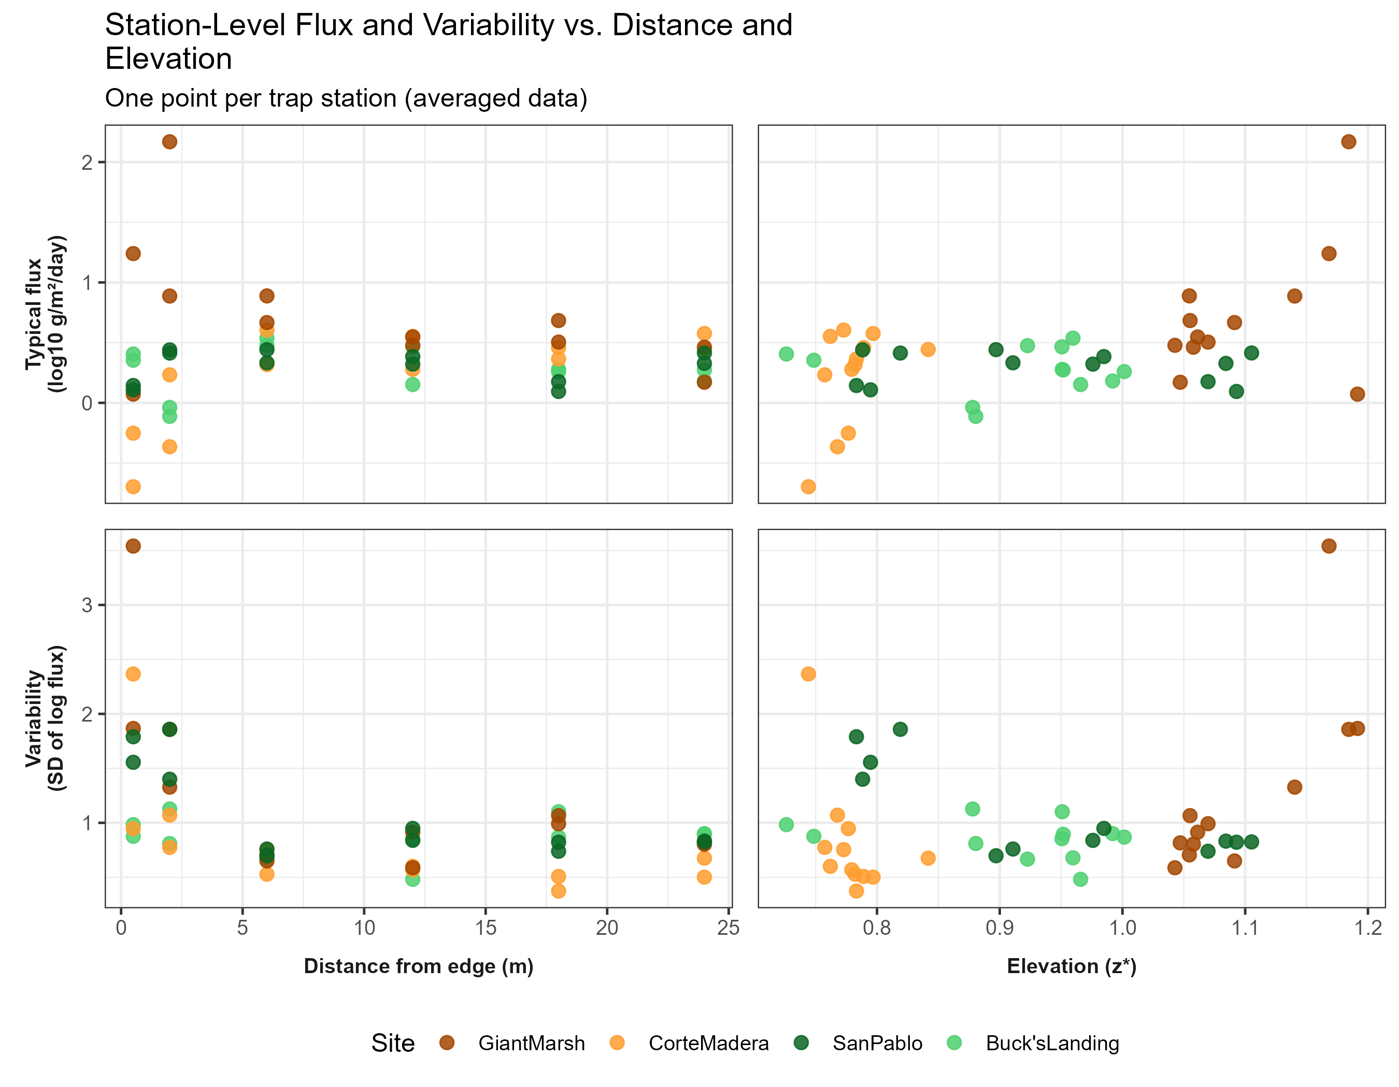
Figure 24. Variance Across Time and Space Between and Across Sites of Sediment Deposition (Flux)
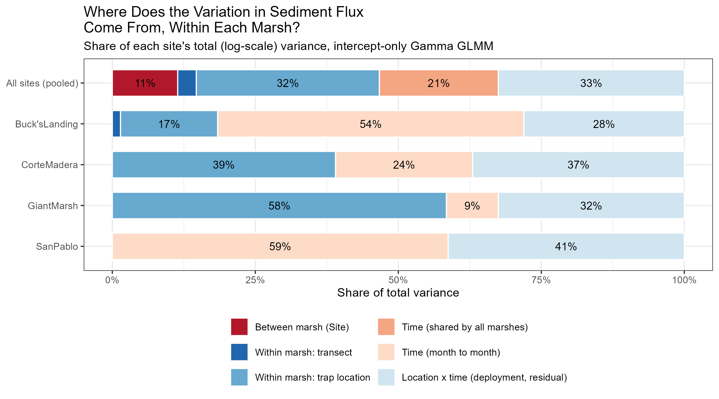
Figure 25. Sediment Deposition (Flux) Across z star profiles Across Marsh Sites
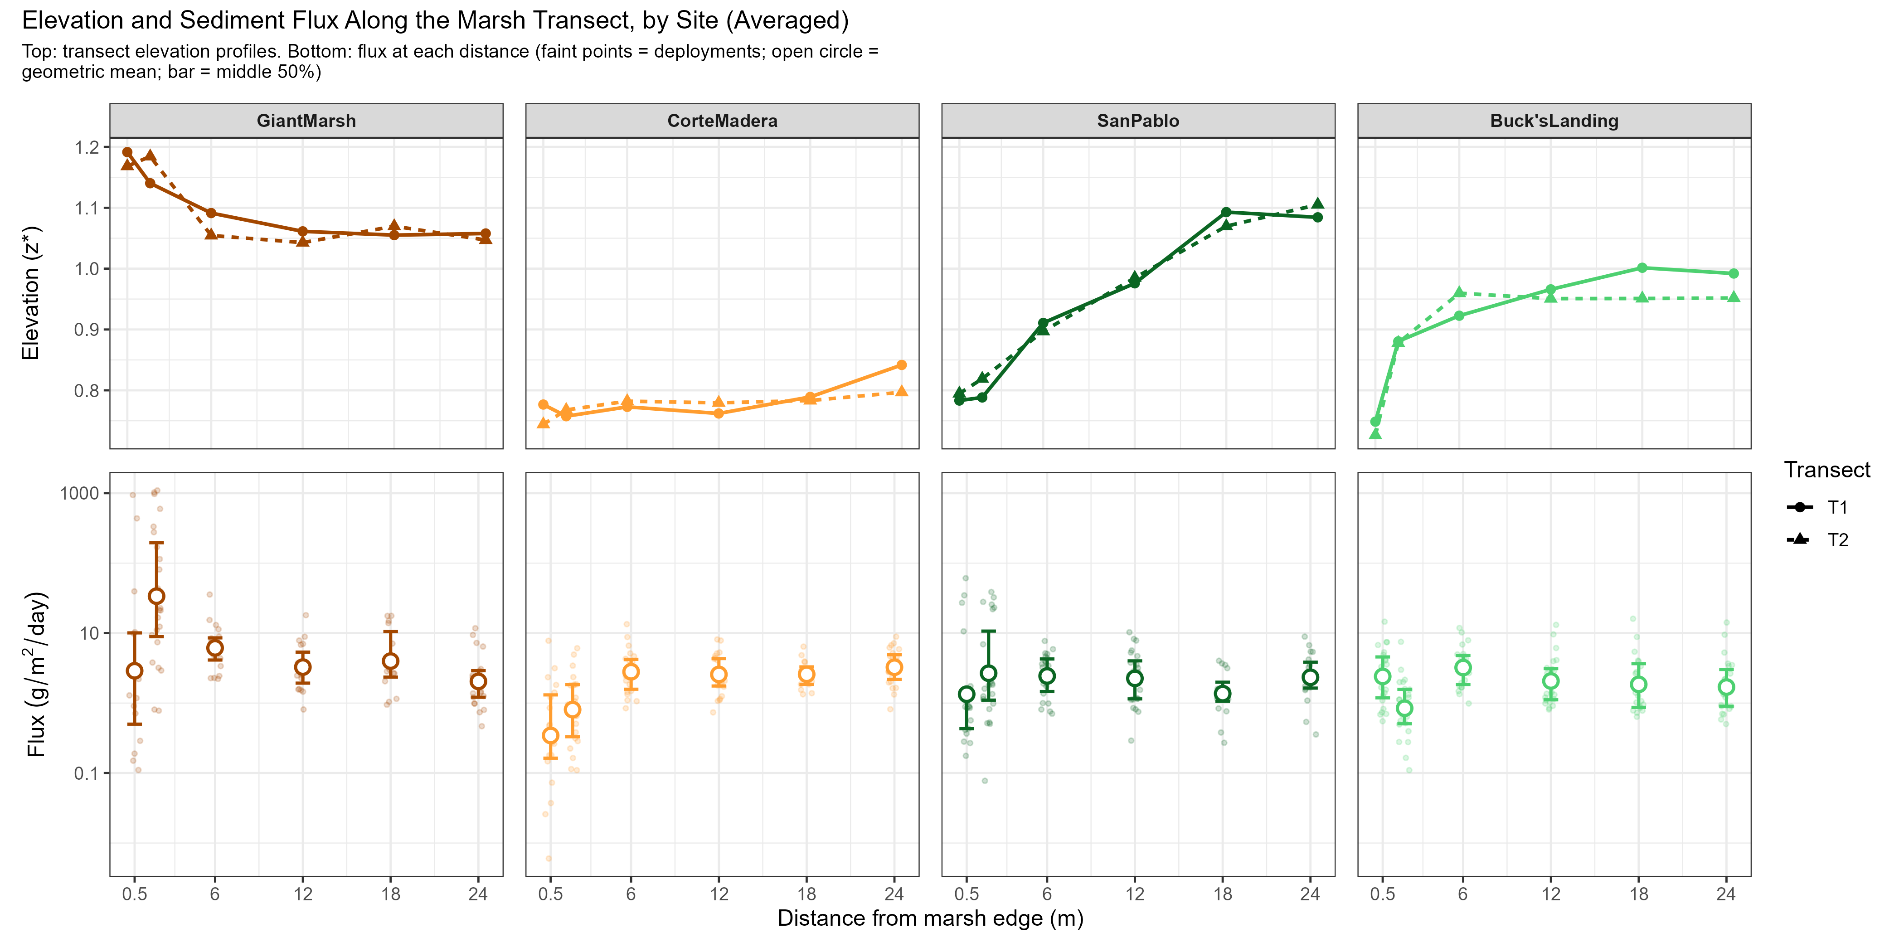
Figure 26. Sediment Deposition (Flux) Across Distance Over Study Collections Between Sites
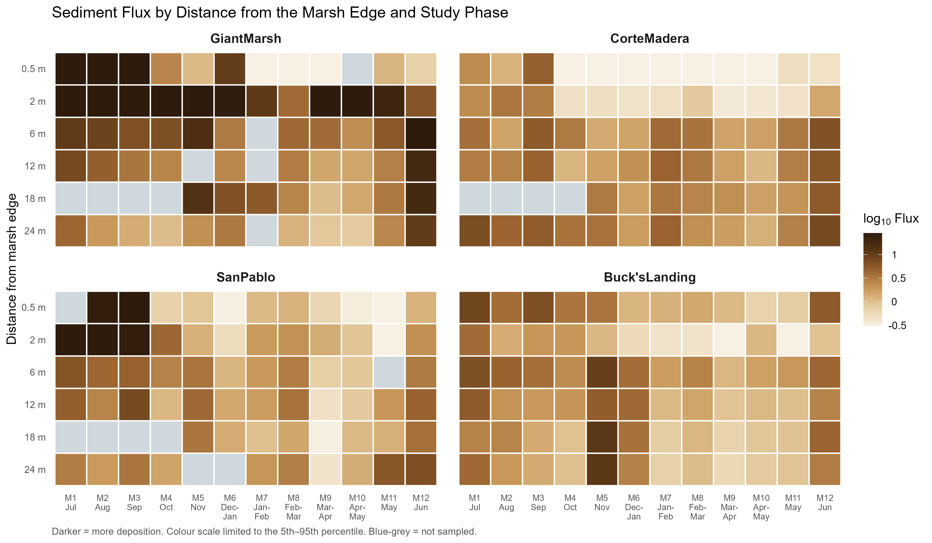
Figure 27. Corte Madera Site Case Study of Sediment Deposition (Flux) Across Distance from Marsh Edge Across Study Collections Between 2022/2023 vs. 2025/2026
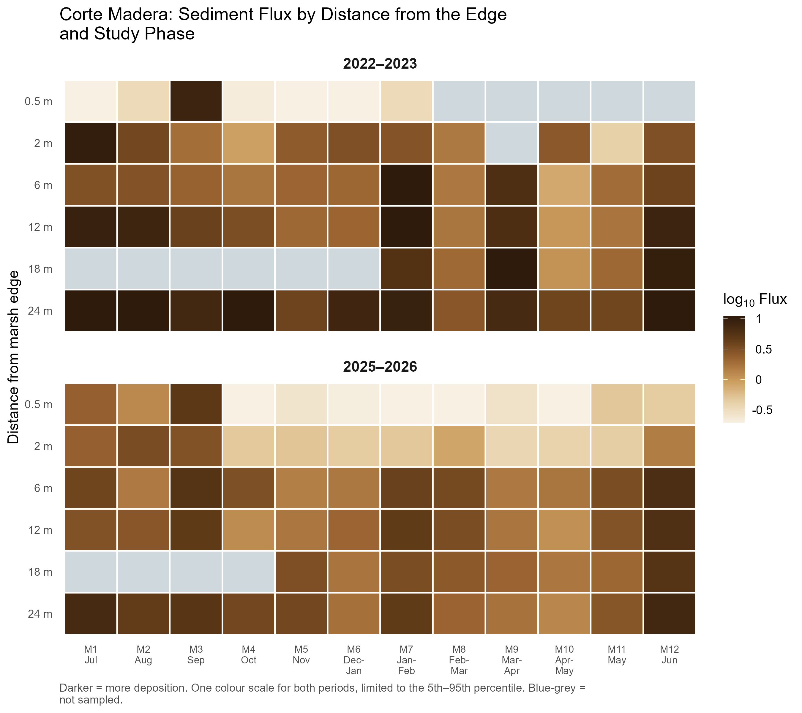

5. Discussion
Figure 28. Distribution of Values Between Ramped and Scarped Marsh Sites
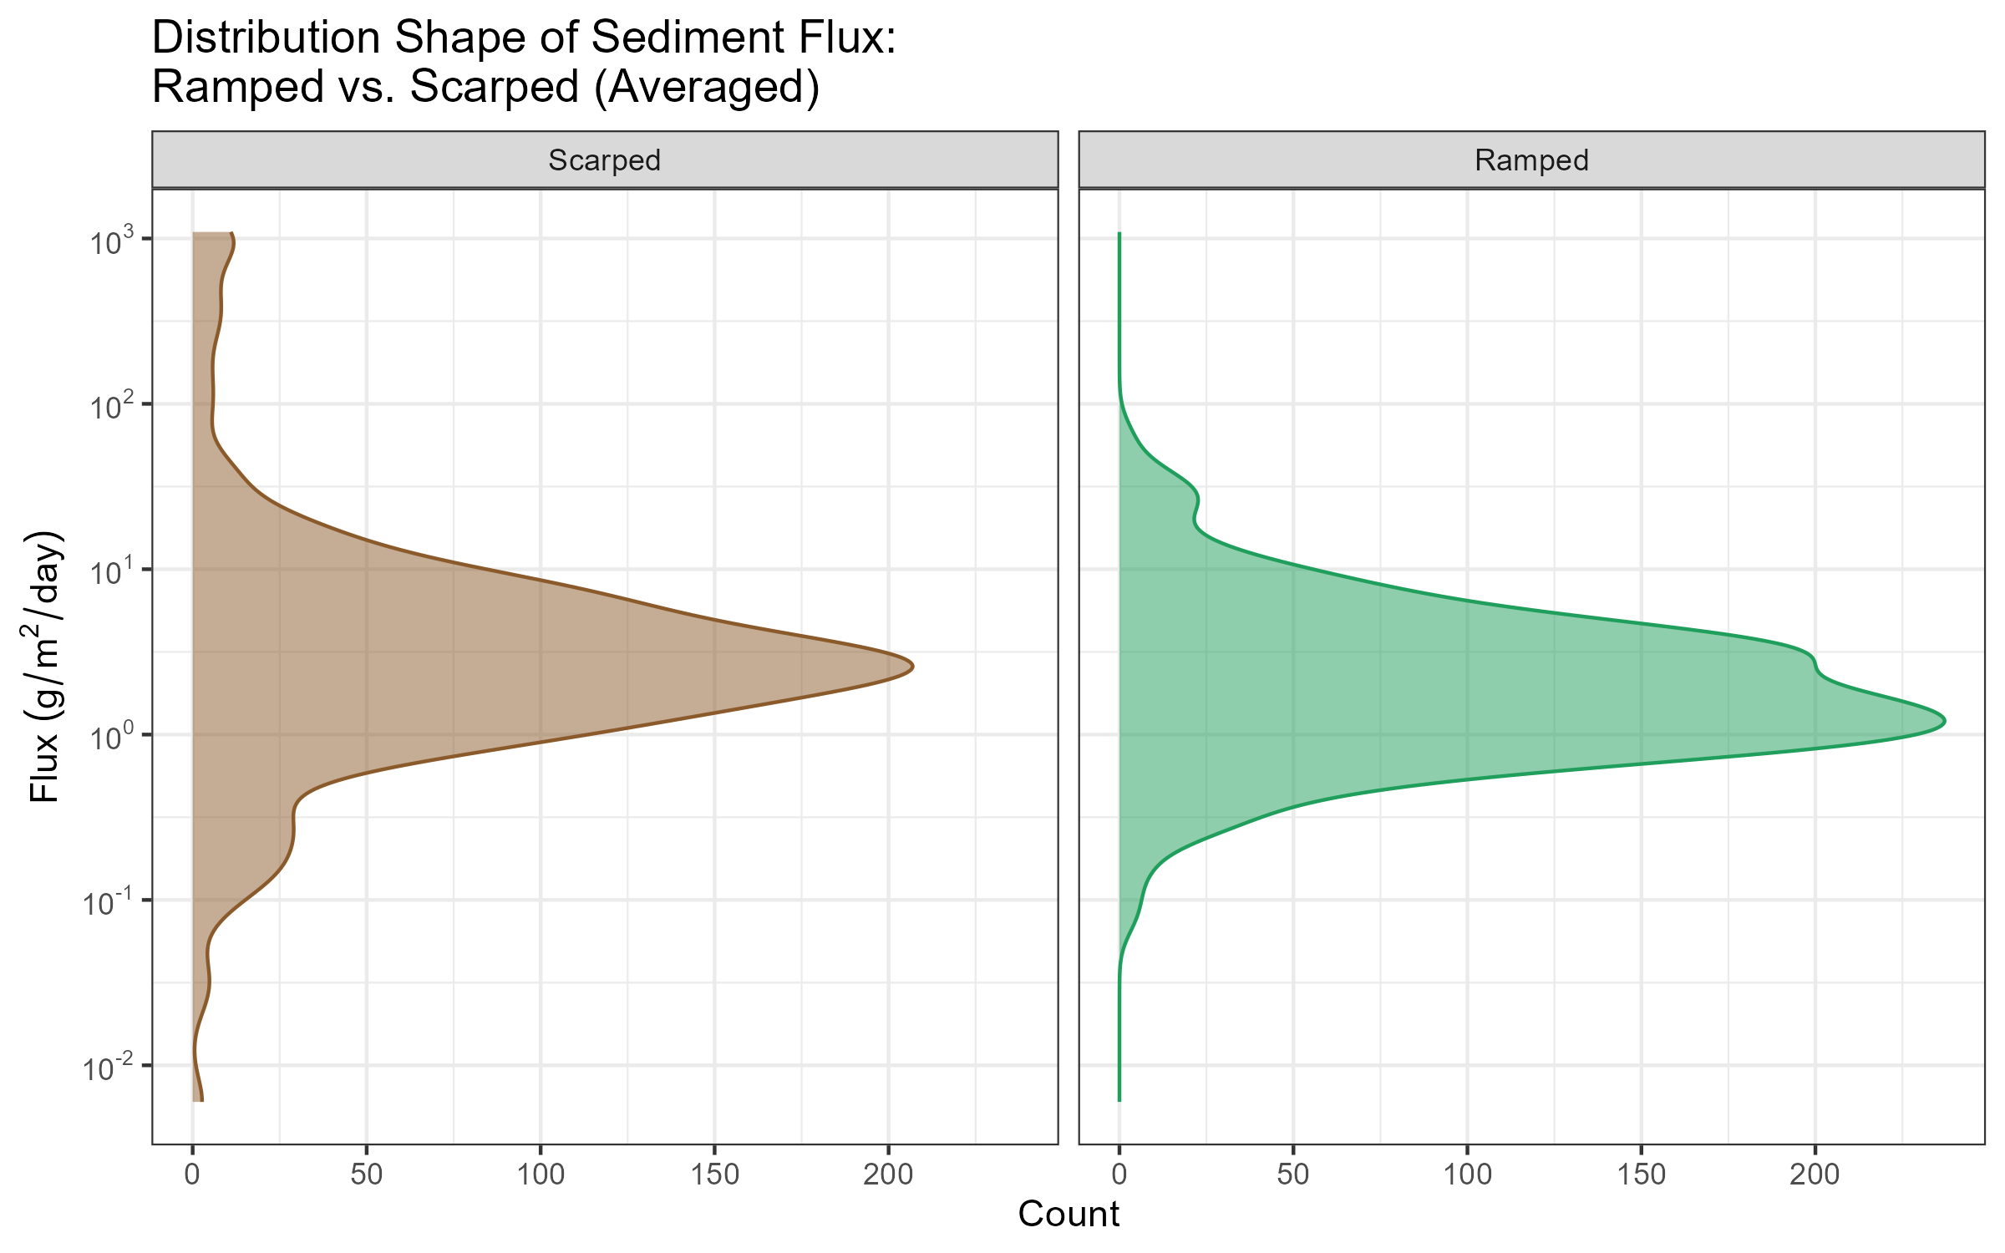
Figure 29. LASSO Analysis Adjusted Per Site
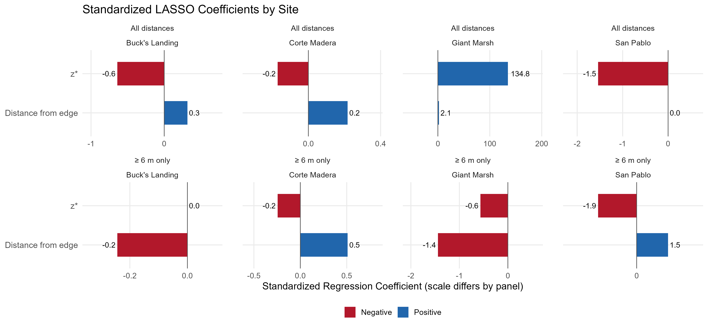
Figure 30. Average Precipitation Between 2022/2023 and 2025/2026 from San Francisco Bay (will get exact tidal station information)
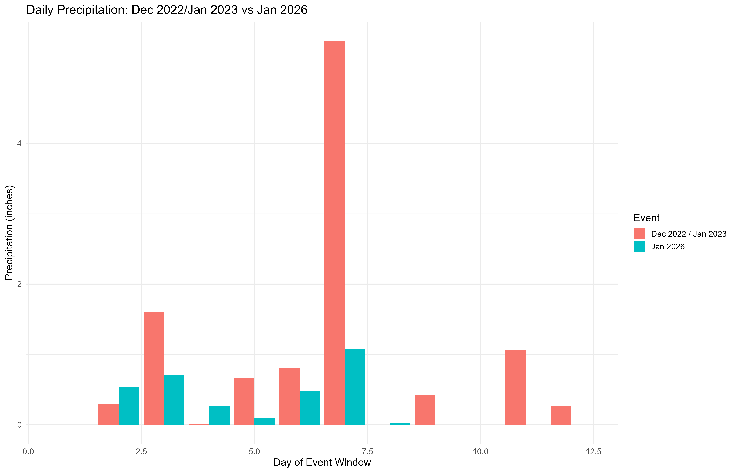
Figure 31. 2022/2023 and 2025/2026 Distribution Plot Comparisons Between Corte Madera Marsh and San Pablo Marsh
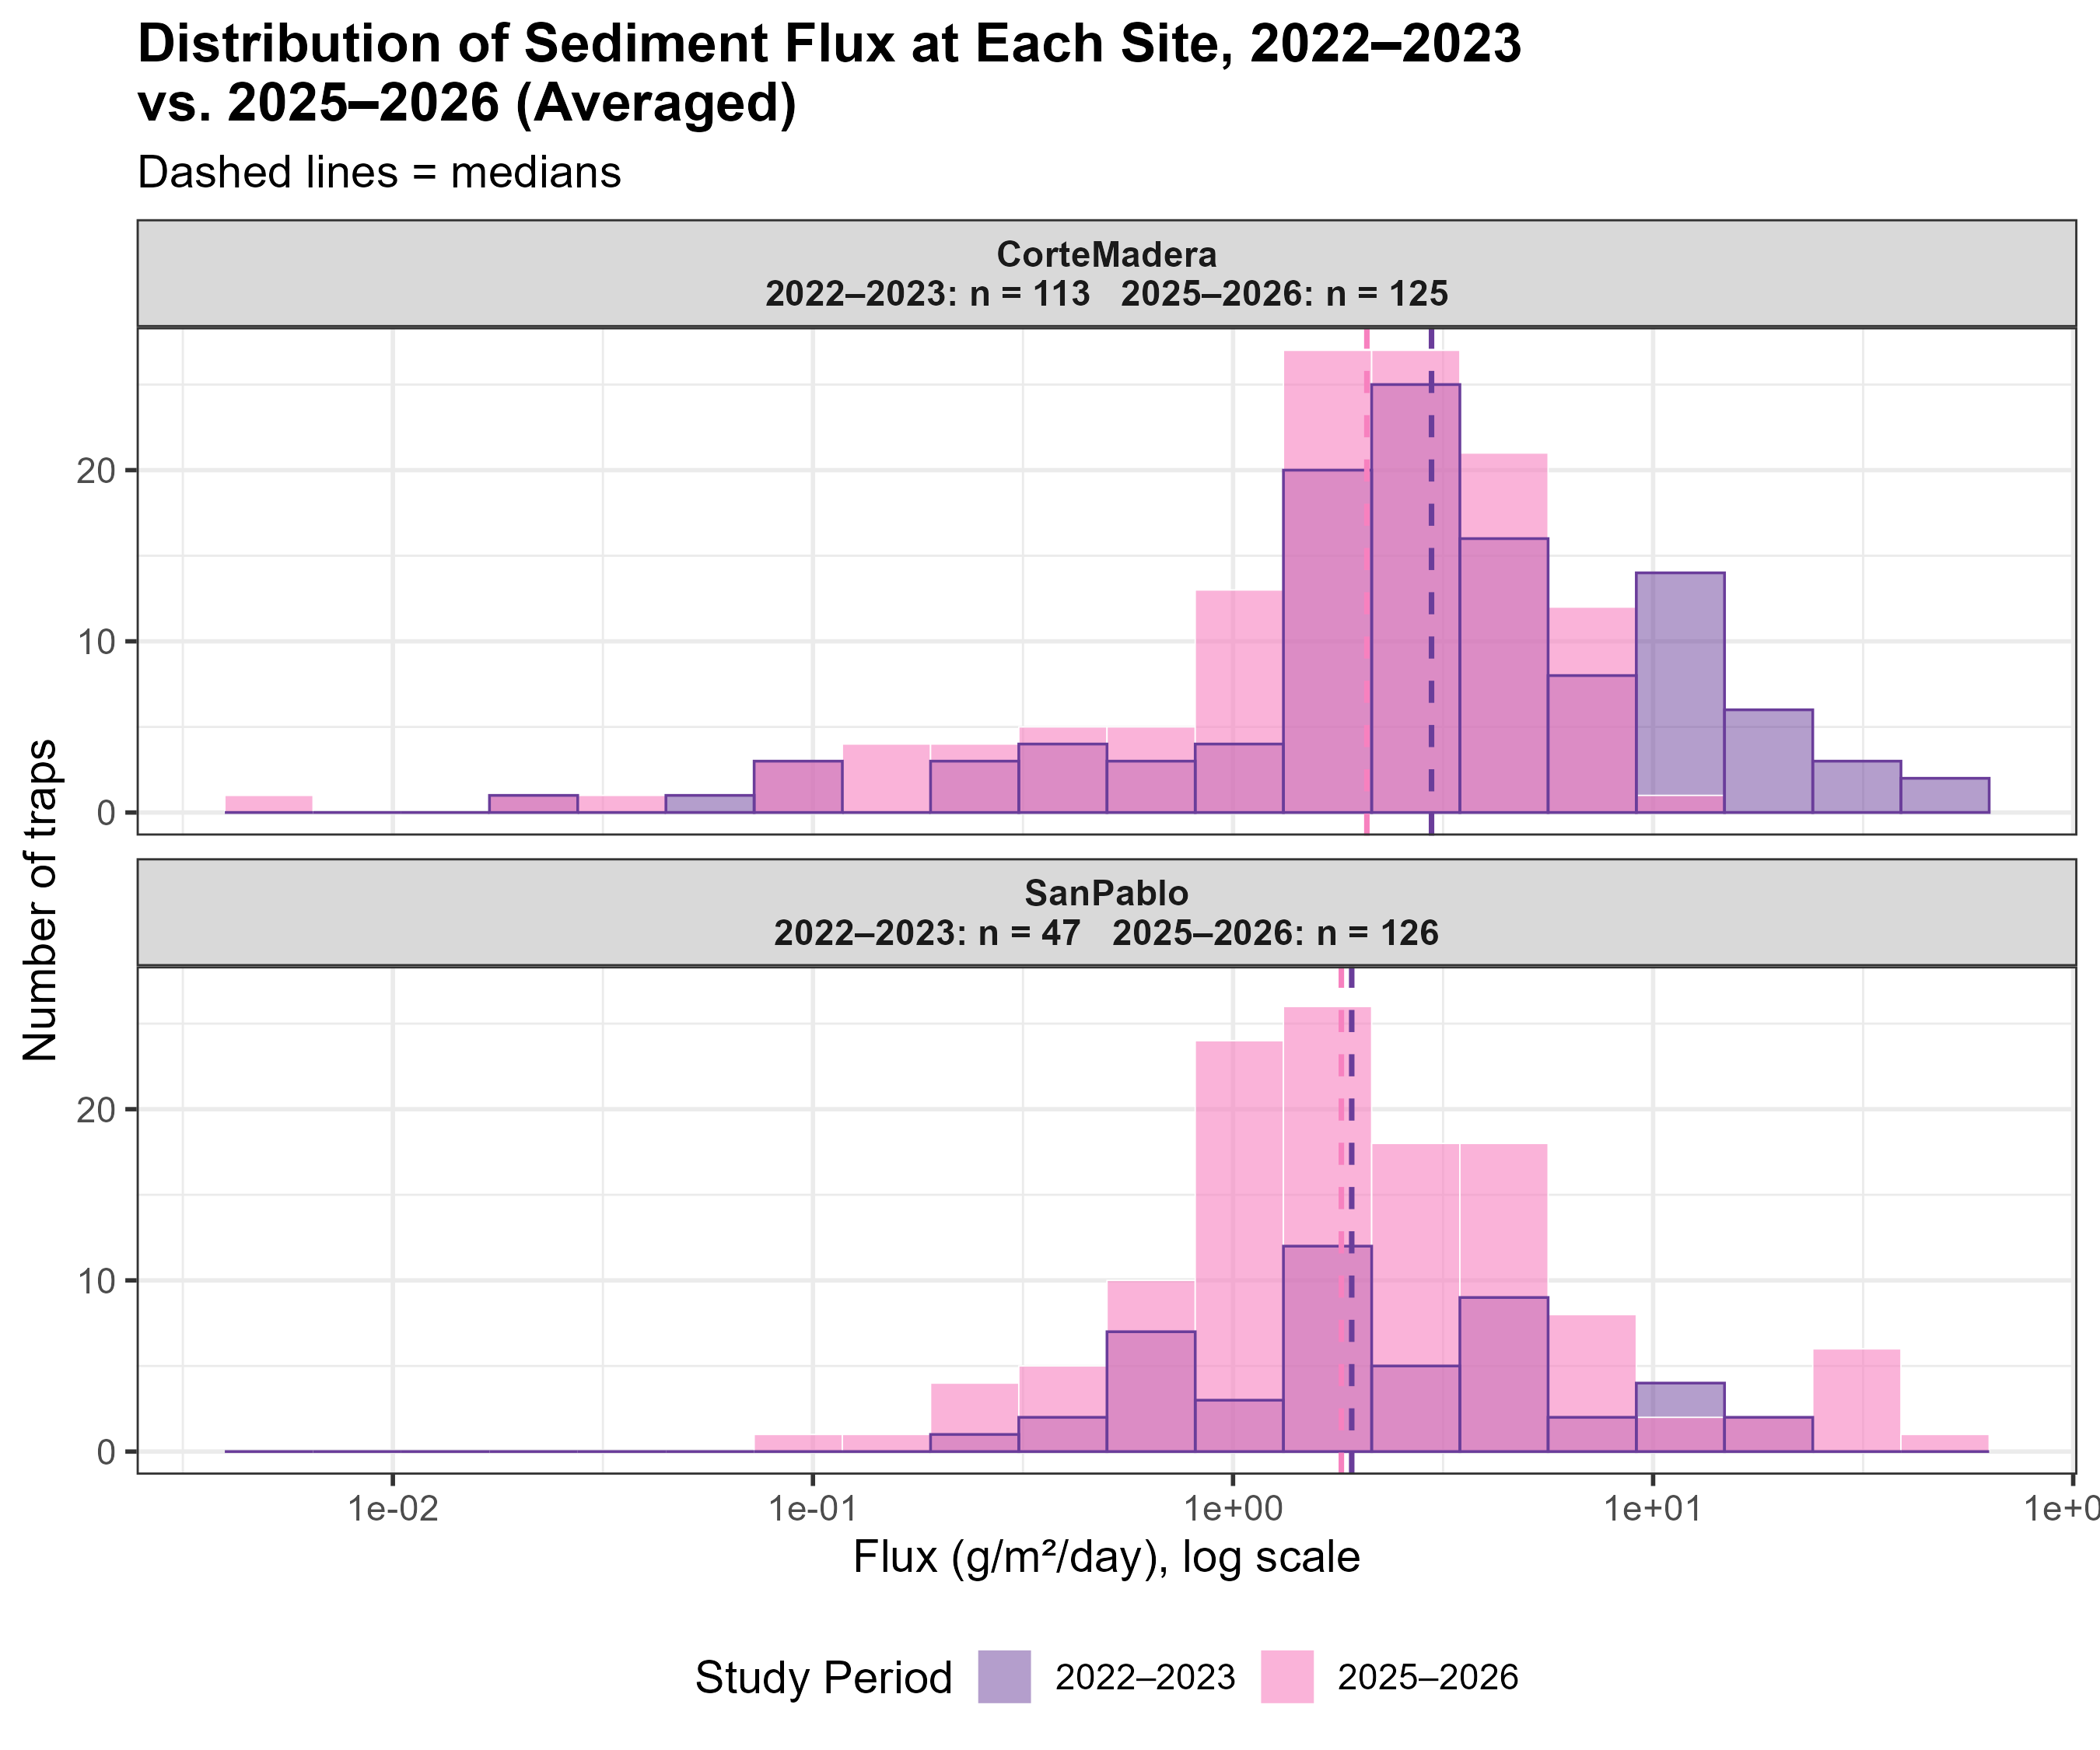
Figure 32. San Pablo 2022/2023 Unvegetated Marsh Sampling Points Incorporated Within Study


